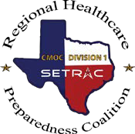

Tier 1 Requirements

Documentation Request Form

2023-2024 RHPC Excellence in Preparedness Award –

Partnering Organization

I am requesting the below documentation to complete the RHPC Excellence in Preparedness Award Packet.

TIER 1 Category
EMS/RHPC Corridor/RHPC Board Meeting Attendance (6)
Symposium Attendance (2023)
Participation in Regional Exercise
Designated Agency Emergency Management Representative/Planner

Name (First, Last):
Facility:
Email Address:
Phone Number:
Date or Date Range of Requested Documentation:

After completion, click HERE to submit to SETRAC and receive email acknowledgment.

