Regional Healthcare Preparedness Coalition Excellence in Preparedness Award
2023-2024 LTC Application Guide

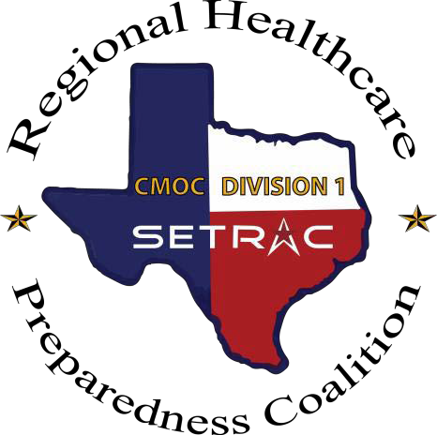

Award Overview
The Regional Healthcare Preparedness Coalition (RHPC) Excellence in Preparedness Award recognizes excellence and commitment to comprehensive emergency management in the regional healthcare community. This document will provide detailed information and identify documents necessary to successfully complete the RHPC Excellence in Preparedness Award application.

Award Timeline
The scoring period will run from July 1, 2023 to June 30, 2024. Applications will be due August 31, 2024 and the selection committee will convene in September.

Award Scoring
Scoring will be comprised of two tiers:
- Tier 1 – Will be scored based upon reports and training requirements determined by the RHPC agreement and ASPR Healthcare Preparedness Capabilities.
- Tier 2 – Will allow the facility to show how they have embraced comprehensive emergency management through innovation, leadership, and community involvement.
- Bonus Points – Available in Tier 1 and Tier 2

Submission Instructions
Applications should be submitted in a 3-ring binder not to exceed 1.5” in depth. Binders should be mailed or delivered to the address listed below. Electronic submission will not be accepted at this time. Tabs should be used to separate the different sections of the application packet. Attached documents should be included as appendixes to their respective section of the application packet. Only one (1) submission per facility (as defined by individual HPP agreement) will be accepted.

Mailing Address
South East Texas Regional Advisory Council
Attn: RHPC Excellence in Preparedness Committee
1111 North Loop West, Ste 160
Houston, TX 77008

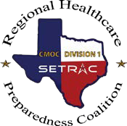

Award Packet Cover Page

RHPC Excellence in Preparedness Award – LTC

Name: Job Title: Facility: Address:

Phone Number: Email Address:

Award Category Applying for (Select One):
  - Skilled Nursing
  - Assisted Living Facility
  - Independent Living Facility
  - Other __________________

*After completion, print this page for your award application packet

Award Submission Checklist
RHPC Excellence in Preparedness Award – LTC

Please use the below checklist to ensure all documentation and information is included for submission.

- Applicant Information Completed

- TIER 1 Cover Sheets

- TIER 1 Documentation

- TIER 2 Cover Sheets

- TIER 2 – Three Essays (limit 1,200 words each | support documentation encouraged)

- Three Ring Binder (1.5” depth maximum) with Binder Cover Sheet

*After completion, print this page for your award application pack

TIER ONE SCORING – MAXIMUM 40 POINTS PER FACILITY
Technology Drills (Bed Reports) – Points will be awarded for your completion percentage during the previous fiscal year (July-June). Reports will include both drills and real events.

- 90%-100% – 5 points
- 80%-89% – 3 points
- 75%-79% – 1 point

SETRAC will provide bed report participation data upon receipt of documentation request form.

Corridor Meeting Attendance – A facility representative must complete the sign-in sheet at their scheduled Corridor Meeting. Multiple representatives will only be counted as one for your facility.

- 6 Meetings – 1 point for each meeting attended (or canceled)

SETRAC will provide Corridor Meeting attendance data upon receipt of documentation request form.

Quarterly Meeting Attendance – A facility representative must complete the sign-in sheet at their scheduled Corridor Meeting. Multiple representatives will only be counted as one for your facility.

- 4 Meetings – 1 point for each meeting attended (or canceled)

SETRAC will provide Quarterly Meeting attendance data upon receipt of documentation request form.

Symposium Attendance – A facility representative must register and attend the RHPC Symposium. Multiple representatives will only be counted as one for your facility.

- 5 points

Attendance will be verified by submitting a certificate of attendance for the RHPC Symposium with your application.

HPP Agreement – A fully executed copy of the HPP Agreement is on file.
- 5 points
SETRAC will verify you have an HPP Agreement on file upon receipt of documentation request form.

Participation in the Regional Exercise – Must satisfy "Conditions for Participation" set by the Exercise Director.

- 5 points

SETRAC will verify participation upon receipt of documentation request form.

Designated Emergency Management Coordinator – The facility has a designated individual who is responsible for the development and implementation of the emergency management program. You must show documentation by submitting your appointment letter as Emergency Management Coordinator signed by leadership, i.e. HPP Agreement.

- 5 points

Bonus Points:

RHPC Oversight Committee/Corridor Chair or Vice-Chair or RHPC Subcommittee Member – Describe names and number of facility staff serving in these roles and contributions made to the committees/subcommittees. Entries will be scored on a scale of 0 to 5 by the selection committee.
- 0-5 points

TIER TWO SCORING – MAXIMUM 20 POINTS PER FACILITY
Applicants must demonstrate commitment to enhancing emergency preparedness at their facility. Please select only 3 fields from the choices (A-F) below. Each selected field will be scored on a scale of 0 to 5 by the selection committee. Contributions must reflect how the facility and not just the Emergency Manager are exemplifying best practices and a commitment to emergency management.

- Leadership Support – How has your executive leadership team demonstrated commitment to emergency management at your facility beyond executive attendance or membership on your facility preparedness committee?
Examples may include: An Emergency Management Department with an individual budget, facility participation with emergency management educational opportunities, and attendance in national training centers such as the Center for Domestic Preparedness.

- Contribution to Emergency Management – How has your facility contributed beyond regulatory, accreditation, or grant requirements?
Examples may include: A published article or speaking engagements on emergency management regarding your facility.

- Community Involvement – How has your facility demonstrated involvement with regional emergency management efforts?
Examples may include: Participation in regionally significant events such as staffing CMOC, active planning and participation in your Local Emergency Planning Committee (LEPC) or Council of Government (COGs), community emergency preparedness education events, or supporting your local Community Emergency Response Team (CERT) program.

- Innovation – What have you done to improve the emergency management process or enhance preparedness at your facility?
Examples may include: Using facility mass notification system to poll for staffing availability or adopting “plain language” for notifications instead of vague codes.

- Planning – How has your facility demonstrated mitigation, identification, assessment and planning of the top 3 hazards facing your facility?
Examples may include: Implementing “Run, Hide, Fight” training or engaging “building champions” to verify available ride-out staffing accommodations.

- Other – Has your facility participated in or hosted training or educational opportunities above the NIMS and ASPR grant requirements?
Examples may include: ICS 300/400 courses or Weapons of Mass Destruction (WMD) course. Has your facility received special recognition for emergency management or other preparedness activities (excluding the RHPC Excellence in Preparedness Award)?

Bonus (0-5 Points): Application Binder Presentation – What extra steps have you taken to prepare your binder to highlight your facility’s preparedness for the selection committee?
Examples may include: Entire binder was attractive, creative and assembled as requested. Essays were very descriptive with meaningful support documentation such as event photos, community articles, thank you letters, leadership support, etc.

FOR MORE INFORMATION OR ANY QUESTIONS, PLEASE EMAIL: rhpcaward@setrac.org

