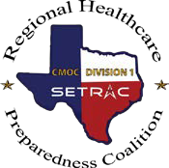

Tier 1 Requirements

Documentation Request Form

2023-2024 RHPC Excellence in Preparedness Award – LTC

I am requesting the below documentation to complete the RHPC Excellence in Preparedness Award Packet.

TIER 1 Category
Technology Drills: Bed Reports
Corridor Meeting Attendance
Quarterly Meeting
Symposium Attendance (2023)
HPP Agreement on File
Participation in Regional Exercise
Designated Emergency Manager

Name (First, Last):
Facility:
Email Address:
Phone Number:
Date or Date Range of Requested Documentation:

After completion, click HERE to submit to SETRAC and receive email acknowledgment.

