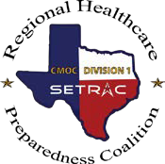

Tier 1 Requirements

Documentation Request Form

2023-2024 RHPC Excellence in Preparedness Award – Hospitals

I am requesting the below documentation to complete the RHPC Excellence in Preparedness Award Packet.

TIER 1 Category
Technology Drills: Bed Reports, WebEOC, and EMTrack
Corridor Meeting Attendance
Symposium Attendance (2023)
Completion of Annual Survey
Participation in Regional Exercise
CMOC Training
WebEOC Training
Decon Training
Designated Emergency Manager
Bonus: NDMS Bed Report Completion

Name (First, Last):
Facility:
Email Address:
Phone Number:
Date or Date Range of Requested Documentation:

After completion, click HERE to submit to SETRAC and receive email acknowledgment.

