- Purpose: to provide hospitals with a concise guide for identifying casualties in the aftermath of a radiation incident who may have received a clinically significant dose of radiation.
- Regional RITN hospital contact information for specialized consultation:
  - U.T. MD Anderson Cancer Center Texas Children’s Hospital
  - Environmental Health & Safety BMT Operations
  - 713-792-2888 832-826-5026
  - Email: askehs@mdanderson.org baburtts@txch.org
- Overview: Ionizing radiation affects the hematopoietic system even at very low doses; hematology and oncology medical staff treat these effects daily. Irradiated patients may develop severe organ dysfunction over time and require intense and specialized management.
- For extensive information on the acute radiation syndrome (hematologic, gastrointestinal, cutaneous, central nervous system), types of radiation incidents, and radiation decontamination, see: www.remm.nlm.gov (Radiation Emergency Medical Management (REMM) website)
- CONSULTATION/REFERRAL CRITERIA: Any patient suspected of having a radiation injury can be discussed with your local RITN center. The ability to accept referrals will depend on the size of the incident and the capacity of regional RITN center(s).
  - Criteria for considering RITN center consultation/referral include:
    - Absolute neutrophil count less than 1,000/µL
    - Absolute lymphocyte count less than 1,000/µL
    - Severe nausea, vomiting and/or anorexia
    - A localized cutaneous radiation injury that requiring extensive management
    - Suspected or known internal contamination (e.g. involving a wound, the lung or GI tract)
    - Current facility not equipped to provide irradiated, leukoreduced blood products
  - Manage comorbidities and possible sequelae of irradiation:
    - See www.ritn.net/Treatment/ for acute radiation syndrome treatment guidelines:
      - Transfuse only irradiated and leukocyte-depleted blood products
      - Administer myeloid cytokines (e.g. G-CSF), if indicated.
      - Provide infection prophylaxis and/or treatment, as indicated
      - Maintain fluid, electrolyte and nutritional balance
    - Also see (REMM) website for Prototype for Adult and Pediatric Medical Orders During a Radiation Incident http://www.remm.nlm.gov/adultorderform.htm
  - Laboratory evaluation:
    - CBC with differential, absolute lymphocyte count (ALC) and absolute neutrophil count (ANC). If <48-72 hours since exposure, repeat q6 hours x 4, then q12 hours x 2, then daily.
    - Serum amylase (may be elevated at absorbed doses > 0.5 Gy)
    - Metabolic panel including electrolytes, renal and hepatic markers
    - PT/aPTT
  - Effects on Bone Marrow Function:
    - Decreased platelet count (<100,000) - clinical presentation includes bruising, petechiae, epistaxis, blood in urine or stool
    - Decreased white blood cell count (ALC<1,000/µL or ANC<1,000/µL) – clinical presentation includes fever and infection
    - Decreased red blood cell count (Hct < 30%) – clinical presentation includes pallor, fatigue, dyspnea with exertion

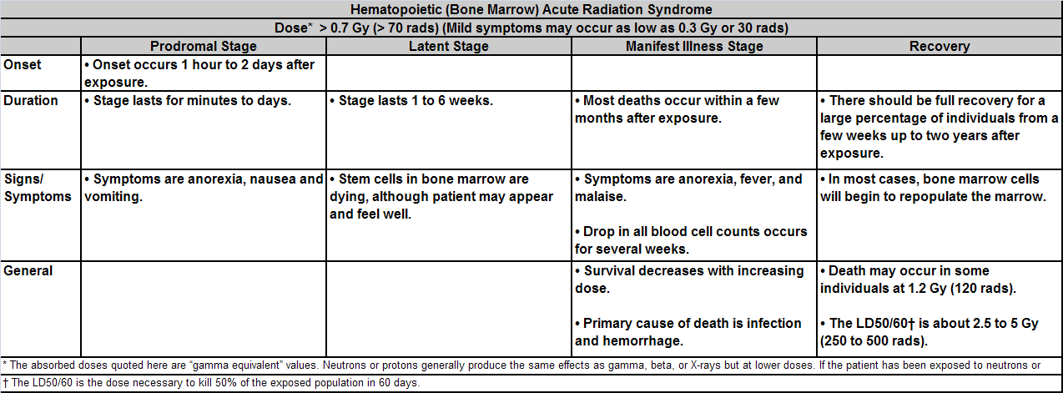

***Guidelines adapted from Dana-Farber Cancer Institute and Primary Children’s Medical Center drafted documents

